**Assignment-Classification**

**1.Problem statement –**

stage1-Supervised learning

stage2-Machine learning

stage3-Classification

**2.Total number of rows-399**

**Total number of columns-25**

**3.Changed String to number – rbc,pc,pcc,ba,htn,dm,cad,appet,ane,classification**

**4. Best model-** Random forest &GaussianNB=0.98

**To find Machine learning Classification method using confusion matrix & classificationReport**

1.**Random Forest**

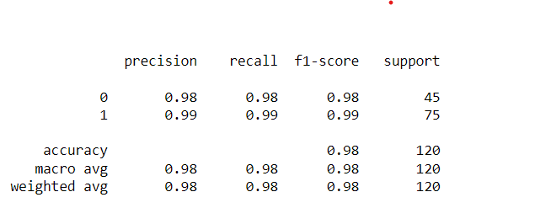



Roc_auc score=0.999

**2.Logistic Regression**

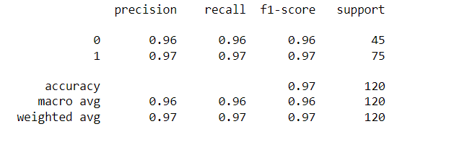

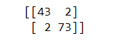

Roc_auc score=0.997

**3.Decision Tree**

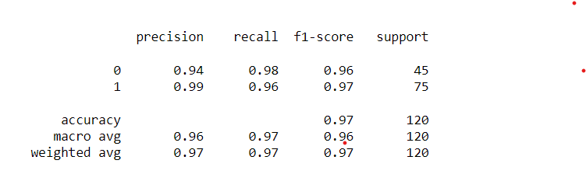

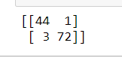

Roc_auc score=0.968

4.KNN

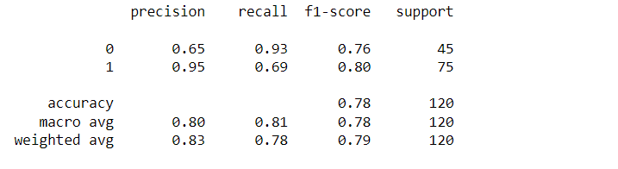

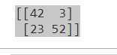

Roc_auc score=0.864

5. Naive bayes

i.GaussianNB

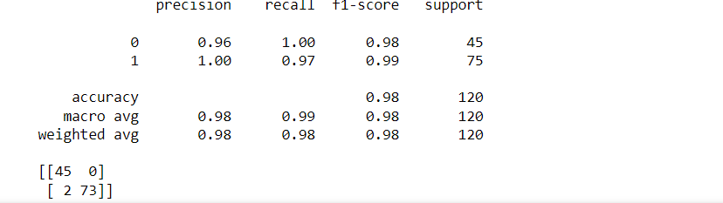

ii. MultinomialNB

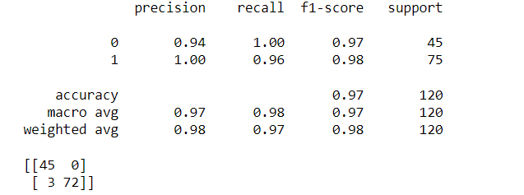

iii.BernoulliNB

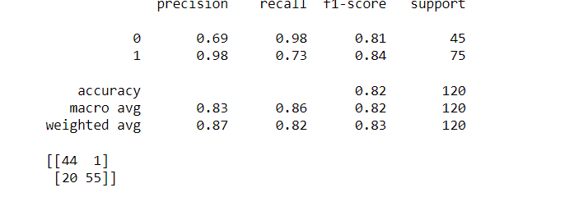

Roc_auc score=0.996

As a result of comparison between multiple Classification algorthim ,We selected random forest&GaussianNB algorthim as best model overall performance Accuracy=0.98